The Viking Influence?
If there is one constant in the ever-changing picture of our history painted by our ancestral DNA, it is the fact that almost every man wants to be a Viking! Perhaps the attraction is the imagined life of a raider, or the intrepid voyages on the open sea in open-decked boats, the sense of adventure or the hats with horns. The latter would have been dangerous to be anywhere near and were the invention of 19th century stage costume designers. But the rest has a certain attraction – and interest.
Because Vikings migrated from Scandinavia in the historic period, the movement of men and their DNA was recorded, particularly by the monks they attacked, and their arrival in Britain and Ireland was relatively recent. Genetic analysis acts as an excellent foil to documentary history and archaeology as it establishes the clear human legacy of the Vikings all over Britain and Ireland. In March we sent you a map that showed the percentages of men who carry haplogroups associated with Norse ancestry in 20
regions across Britain and Ireland. I attach an updated version.
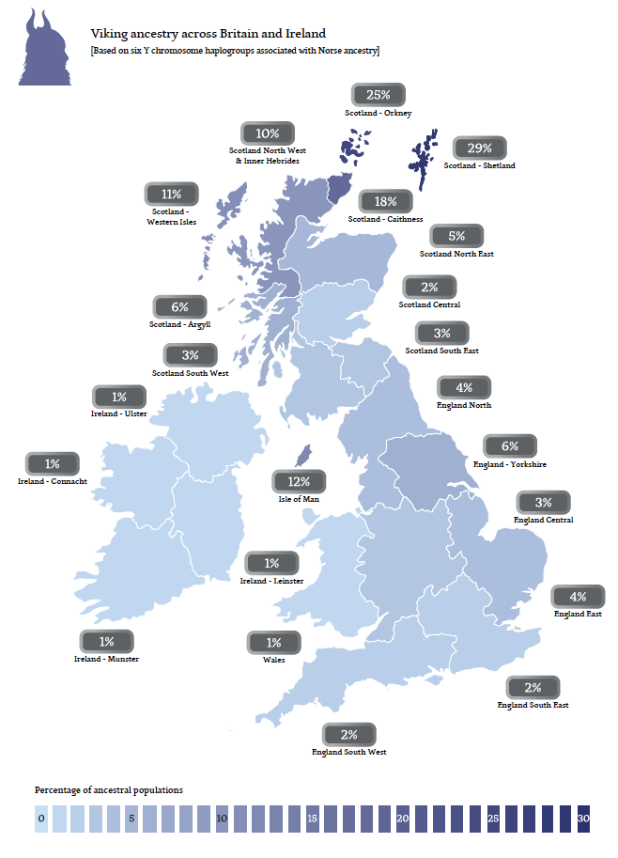
But what no documents or maps record is the traffic in the opposite direction, from Britain and Ireland to Norway. The early Viking raiders certainly killed, pillaged and worse, but later they became much more interested in taking captives. At Dublin, at the mouth of the Liffey, they established a slave market and longships sailed around the coasts of Britain and Ireland to round up men, women and children to be sold there. Many were bought by merchants and sold on to the likes of the Caliphate of Cordoba in Moslem Spain or to the wealthy families of the Eastern Roman Empire based on Byzantium. British and Irish slaves, particularly aristocrats, were much prized. But others were taken east across the North Sea, back to the Viking homelands in Norway in particular. And because slaves were of little or no account, no document records this dismal traffic. It is a story only DNA could tell.
Very surprisingly, the classic British Celtic Y chromosome haplogroup of R1b-S145 is found at a significant frequency of 5% of all Norwegian men. And it is particularly common in the areas along the western seaboard, the places from where Viking longships set sail for Britain, from Nordland, Trondelag, More and Romsdal and Hordaland. There, R1b-S145 is present in between 12% and 19% of all men in the modern population. Most have Irish and Scottish markers. One group carries that of a Pictish type, another has the Ancient Irish marker of R1b-M222 and yet another comes from a Scottish/Irish subgroup. Absence in ancestral DNA can also be informative and these markers are either absent or at very low frequencies in Denmark and Sweden. It seems very likely indeed that the ancestors of these Norwegian men were slaves captured by Vikings in raids on native communities in Ireland and Scotland. And this is not a small trace. In the four regions which have data, about 110,000 men are the descendants of slaves.
What is even more remarkable are the relative proportions of genetic exchange. About 3% of British and Irish men carry Viking lineages but 15% in the four western regions and 5% in Norway as a whole carry British Celtic DNA. It could be argued that the Viking migrations had a profound impact on both sides of the North Sea.
The R1b haplogroup may well be common but it is not carried exclusively by commoners. Prince Philip almost certainly has it and through Prince Charles and Prince William, it has been inherited by little Prince George. Queen Victoria’s consort, Prince Albert, also carried a subgroup, R1b-S376, and Prince Michael of Kent, the Duke of Kent and the Duke of Gloucester and their sons all have it. That means they are all Pretani just like many of the men who have taken the fatherline test. Royal Pretani, but Pretani nevertheless.

Who Are the Welsh?
Recently we have become very interested in DNA samples from Wales. Although they seem to ask more questions than they answer. A good example of the mysteries of Welsh DNA was discovered in the north.
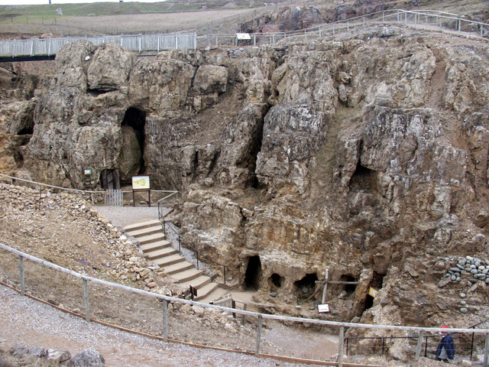
Image courtesy of Alan Simkins
When the Romans came after AD43, many thousands of men brought the Y chromosome DNA of the Mediterranean to Britain as they garrisoned and administered the new province, and we have discovered that it probably left an indelible print in Abergele where a group of 38 men have been found to carry E-V13, a Balkan haplogroup. They were most likely miners at the huge prehistoric copper mine at Great Orme’s Head at Llandudno which was reopened after 43AD. Can we find more traces of the Roman Empire in Wales? Or is there a deeper mystery hidden in the mines at Abergele, a deposit from the prehistoric European trade in tin, an essential ingredient in bronze?
There is also a puzzling link with Scotland. There is a rare group in Wales labeled S530+S749 - which appears to be closely related to the Pictish types we have found in Scotland. This is based on a small sample but may show an ancient connection between early and indigenous Scottish types and indigenous Welsh types to the exclusion of indigenous Irish types. These links are no more than spider threads and without much more sampling, none of us would put our names to them. But these tantalising links may well be there, only more sampling will tell. And all of this speaks to a sense of the Welsh as an old community, perhaps the oldest in the British Isles. We will update you as research progresses.

